Project Financial Tracker v1.2

by

Eric N. Opp
eric.n.opp@gmail.com
Tel.: (571) 218-9428

Table of Contents
Introduction 1
The Application 2
Installing 2
Using the Template 2
Security Settings 2
Opening and Saving 3
Creating a New Workbook 5
Using the Workbook 7
Worksheets 7
Assumptions 7
Graphical Summary 7
Progress Report 8
Labor Categories 11
Task EAC and Total EAC 12
Basis of Estimate 13
View by Name 13
View by Organization 14
View by Task 15
Details Sheets 15
Initial Columns 16
FTE Columns 18
Planned Hours Columns 19
Planned Cost Columns 20
Actual Hours Columns 20
Actual Cost Columns 20
EAC Hours Columns 21
EAC Cost Columns 21
NTE Ceiling 22
Estimating New Projects 23
Tracking Existing Projects 24
When a Team Member Leaves the Project 24
When a New Team Member Joins the Project 25
When a Tem Member Is Assigned a New Labor Category 25
Reconciling Data 26
Other Operations 26
Undoing the Creation 27
Adding New Rows 27
Freezing Panes 28
Unfreezing Panes 29
Hiding Unused Rows 29
Hiding OBE Rows 30
Unhiding All Rows 30
Unhiding Unused Rows 30
Unhiding OBE Rows 30

Introduction
The genesis of this spreadsheet application was a financial tracking spreadsheet that I used on the first project task that I ever had to manage. The workbook itself proved to be a very useful tool in keeping track of the current financial status of a task and/or an entire project. This same workbook also proved to be very handy for creating a basis of estimate or a price quote for new work.
There were several major problems with this original workbook. First, the initial version of the workbook could only handle projects that spanned two years – the number of full months that would effectively fit onto a single worksheet. Second, each time a new project was initiated and/or a new bid was required, an old version of the spreadsheet would need to be gutted and rebuilt. This often created major errors in the formulas yielding erroneous results. Finally adding new rows and hiding rows that were not used became problematic and would result in additional errors injected into the workbook.
For these reasons, I created a VBA application that would automatically generate a complete workbook from an empty spreadsheet and that would facilitate those small tasks that were done manually before so as to reduce the numbers of errors injected into the workbook as its was being used. Finally, I have extended the spreadsheet so that a full five years can be fit into the application. In principle, the number of years included in the application could be extended indefinitely, but I have seen very few projects, whose periods of performance extend beyond five years – particularly in the Government contracting arena.

The Application

Installing
There is a blank copy of the Project Financial Tracker Workbook/Application on the CD along with this document. Since the application itself will be creating new worksheets and modifying the contents of those worksheets based upon the project parameters entered into the application, I would recommend that you copy the application from the CD onto your local hard disk. I would further set the file parameters to be read-only, so that you do not inadvertently save a full project workbook over the blank application. You could also save this application as a template so that you are able to access the template each time you open a new XL spreadsheet.
To save the Project Financial Tracker application as a template that only you have access to, you will need to save this under your profile. For Windows XP, this will be located in the following directory:
C:\Documents and Settings\your_user_name\Application Data\Microsoft\Templates
To save the Project Financial Tracker application as a template that all the users of your machine have access to, you will need to save this in the directory that contains all the templates for Microsoft Office. For Windows XP, this would be in the following directory:
C:\Program Files\Microsoft Office\Templates\1033

Using the Template

Security Settings
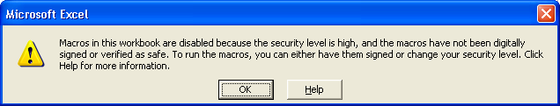
You may have to alter your security settings to be able to use this application. The default setting for Macro Security is high. If you open the workbook and get the error message box shown below, you will have to change the Macro Security within Excel.
To change the Macro Security level to Medium, which is the recommended setting, select the Macro Security Menu Option as follows:
Tools → Macro → Security…
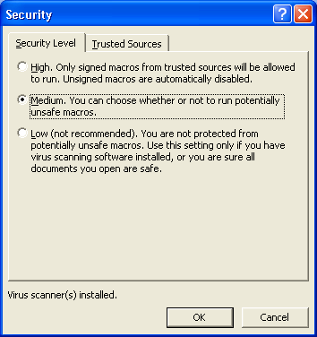
You should obtain the following dialog box in which the Medium option should be selected.
When the security level has been set to Medium, you will be given a choice as to whether to enable or disable the macros and VBA code that come associated with each workbook. Excel must be exited completely and restarted before the new setting will take affect. You will simply need to choose the Enable Macros option when the workbook opens to make full use of the Project Financial Tracking application.

Opening and Saving
The first time that you open the Template or Workbook you will be presented with a blank sheet that is simply labeled “Details”. This starting point and should be the starting point for each new Project Tracking Workbook. This starting point is shown in the figure on the next page.
Once you have opened the Template, you should save it under the file name that you will ultimately be using for your project estimation and project tracking workbook. Do not write over the old file name or the template file, since you will want to start with a fresh Workbook each time you create a new project tracking workbook.
On the menu bar, there is a selection labeled PM FIN Tracker. This menu option gives you the controls that allow you to Create a new Project Tracking Workbook, Undo the creation operation that you have just done, Add New Rows, Freeze Panes and Unfreeze Panes on the Details sheets, and Hide and Unhide rows based upon some specific criteria.
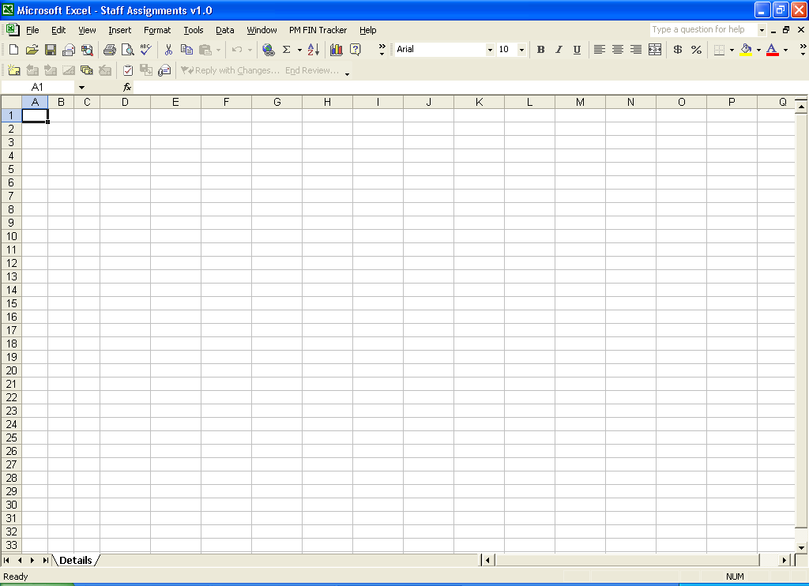
The first step in using this application to estimate and track a given project, is to Create a new workbook. Do not be overly concerned that your first attempt be correct, since you can always undo all your work and start over again.

Creating a New Workbook
Creating a new workbook is rather simple. Each project that you will track has a number of simple parameters associated with it. These parameters are basically the following:
- Number of Tasks;
- Number of Subtasks;
- Number of Project Roles;
- Number of Labor Categories;
- Number of Team Members;
- Project Start Date;
- Duration in Months; and
- Number of Organizations.
These parameters should be self-explanatory for most experience project managers. For the few that may not be so obvious, the definitions are given below:
The Number of Project Roles is the number of different categories of roles and responsibilities that are present in the project. For example, the project roles on a data warehousing project might be the following list:
- Project Manager;
- Data Warehouse Architect;
- Database Administrator;
- Extraction, Transformation and Load Programmer;
- On-Line Analytical Processing Programmer; and
- Business Analyst.
Since a single team member may fill numerous roles, you want to make sure that you allow yourself enough slots under both the Number of Team Members as well as the Project Roles to accommodate the entire team.
The Number of Labor Categories refers to the number of different pay grades or estimation and billing slots there are for the individual team members. If your project is small enough or the requirements of the contract dictate that you bill at cost plus some fee or profit, you may want to create a single labor category for each member of the team. This will make estimation and tracking somewhat cumbersome, but you certainly can use the workbook in this manner.
Finally, the Number of Organizations refers to the number of different companies or entities involved in the project. If there is only a single entity involved, then the Number of Organizations is simply one. If you are the prime contractor and you have s single sub-contractor, then the Number of Organizations is two.
When you have your project parameters ready, select the menu option:
PM FIN Tracker → Create New Workbook
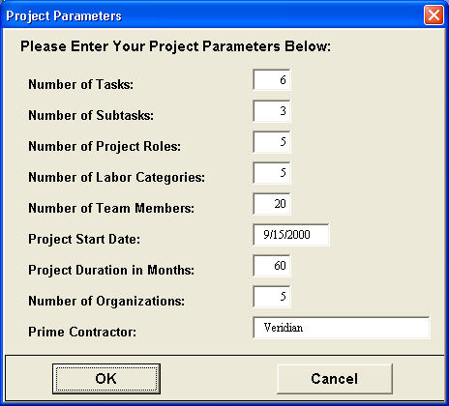
When you select this option, you will see the dialog box below appear over the blank worksheet. You simply enter you project parameters into the appropriate text boxes as show in the figure below.
When you have completed all your entries correctly, hit the OK button, and the VB application will do its magic, and you will have a fully created workbook in about a minute. This workbook contains all the sheets, charts and pivot tables required for you to estimate, track and control your project. If you feel you have made a grave error, simply select the menu option:
PM FIN Tracker → Undo Creation
This will put the workbook back into the state in which you started. You can then cerate a brand-new workbook with a new set of parameters.

Using the Workbook
This section describes the function of the different sheets in the workbook and how they relate to each other. There are a series of Details sheets that contain most of the data that you will need to input to estimate and track your project. We will follow the example using the parameters entered above to describe the function of each of the sheets and each of the sections of the Details sheets.

Worksheets
Each Workbook contains one or more of the following worksheets:
- Assumptions;
- Details;
- Graphical Summary;
- Progress Report;
- Labor Categories;
- Task EAC;
- Total EAC;
- Basis of Estimate;
- View by Name;
- View by Organization; and
- View by Task.
Each of these sheets is described in a separate section below. I have left the Details sheet for last, since it is the most complicated.

Assumptions
The Assumptions sheet is a blank sheet that you can use to list the assumptions that you use to create the initial project estimate. You may choose not to use this sheet at all, if the assumptions that you made in creating the workbook are obvious or are documented elsewhere. Since I do so many estimates using this workbook, I prefer to have the assumptions right in the front, so that I do not need to remember which estimate goes along with which set of assumptions. This is particularly important when you are using the worksheet for the purpose of creating a bid strategy and comparing different options. By all means, if you do not need this sheet, you may feel free to delete it.

Graphical Summary
You should never need to touch this worksheet. This sheet contains a set of formulas that provide the totals for the Project Tracking Charts that are displayed in some of the latter sheets. Before any data gets input into the Details Sheets, this sheet should simply display column after column of $0, which represents no Planned Costs, no Actual Costs and no Estimated Actual at Completion (EAC) Costs. As you enter data into the Details Sheets these values will change. Again, do not edit the formulas on this sheet. The only reason ever to edit this worksheet is to change the default value for the Threshold Percentage for the EAC Charts.

Progress Report
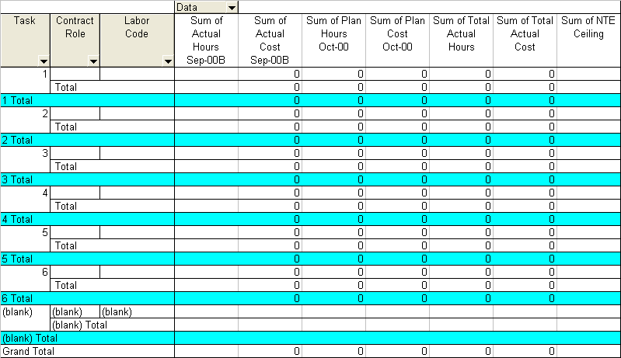
This sheet contains a blank pivot table report. This pivot table report is a blank progress report that can be used as a starting point when reporting the financial status of your project. For the default creation settings, the progress report is shown below.
The table itself shows no values, since the data in the Details sheets is blank and/or zero. As you begin to fill data into the Details sheets, you can refresh the data in the pivot table and get a full-fledged progress report after the first complete month of your project.
The column headings in the report are keyed to the first and second months of the project as specified in the Project Parameters dialog box. For subsequent months, you will simply need to remove the values for the old month using the Pivot Table Wizard and add the values for the new month.
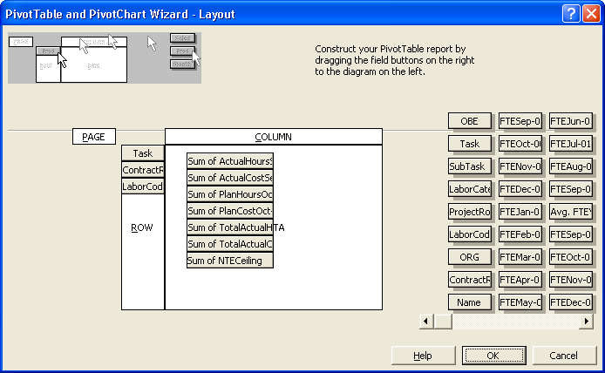
To get to the pivot table wizard, simply right click on any of the cells within the table. This will bring up a menu selection that includes the icon for the Wizard. When the final dialog box for the Wizard appears, select the Layout option. You will see the following window.
To remove the Actual Hours and Actual Costs for September ’00, drag the individual Actual boxes out of the data area onto the gray space to the right of the table layout. To add the Actual Hours and Actual Cost for October ’00 find the boxes marked Actual Hours Oct-00 and Actual Cost Oct-00 in the list to the right. You will need to scroll through the list of boxes until you find the section where the Actual values start to find the boxes that represent the Actual Hours and Actual Costs for October. Drag these two boxes into the white Data field into the same positions that the boxes for September were in. Your result should look like that on the next page.

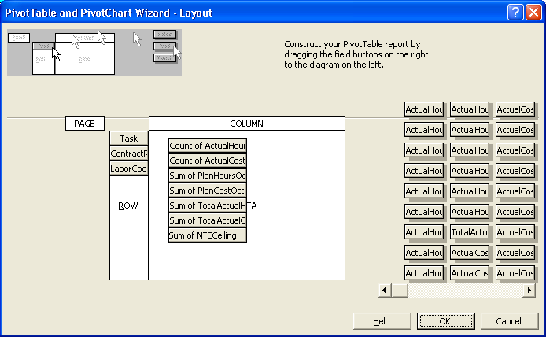
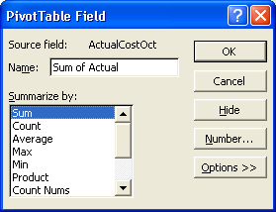
You will notice that the two boxes now show the Count of Actual Hours and the Count of the Actual Cost as opposed to the sum. You will need to double click on each of the individual boxes to select the Pivot Table Field Properties as shown below.
Simply select Sum and click OK. You will need to do the same with the Planned Hours set as well. Finally, select OK on the Layout Box and Finish on the Pivot Table Wizard. At this point, you will have a new Progress Report. If you change the data in the Details sheets before you wish to submit your progress report, simply refresh the Pivot Table after you have updated the values.

Labor Categories
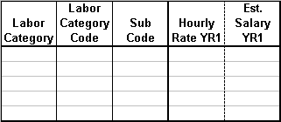
The LaborCats sheet allows you to specify the different Labor Categories and the associated hourly rates for each of those categories. The first section of the empty Labor Categories table is shown below.
The first column – Labor Category – allows you to enter the full name for the labor category that you will use to estimate and track the project being modeled. The next column allows you to enter a Labor Category Code or abbreviation for the estimation and tracking. This code will be used in the Details sheet(s) as the reference, which determines the rate that will be used for the Planned Cost, the Actual Cost and the EAC Cost in the Details sheets. The next column provides a reference column should a sub-contractor report their labor hours and rates using a different rate code. For example, the project manager may be assigned to the Project Manager Labor Category, which has a PM Labor Category Code, which is reported by a subcontractor as A1.
Finally, there are two columns for every year for the Hourly Rate and the Estimated Salary. The Hourly Rate for each year should be the fully loaded hourly rate or the hourly rate that is or could be charged directly to the end customer. In other words, this should include the hourly rate, which has been derived directly from the average salary for a given Labor Category, burdened with any overhead associated with that Labor Category, any General and Administrative costs associated with that Labor Category as well as profit.
There are no formulas inserted into the Estimated Salary column for each year, since there are a multitude of factors that go into the relationship between the fully loaded hourly rate and the salary. If you have insight into how your fully loaded rates are built up, then you can easily insert the formula for the Estimated Salary into that column.
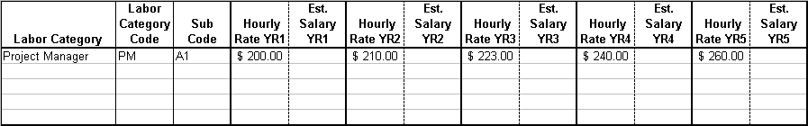
Using the example cited above, the first row of the Labor Categories table might look like the table below.

Task EAC and Total EAC
Each Expected Actual at Completion (EAC) worksheet contains a chart that shows the following four separate graphs:
- Actual Expenditure
- EAC Expenditure
- NTE Ceiling; and
- Threshold.
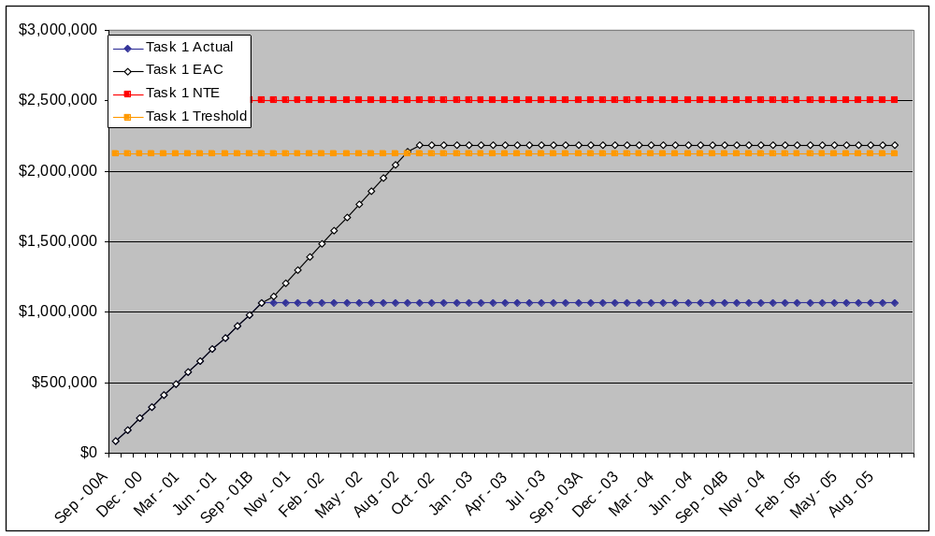
An example of a graph is shown in the figure below.
The red line in the graph represents the Not-To-Exceed (NTE) ceiling for the contract. This would normally be the maximum value of the contract or maximum amount of money that could be charged to the client without a contract modification of some sort. The orange line on the graph represents the notification threshold. For many contracts this point is 85% of the NTE ceiling on the contract. This threshold can be adjusted by adjusting the factor used in the Threshold rows on the GraphSum sheet. Depending upon how you set up your project, this field could be used to indicate the point at which you begin to reduce your expected profit. If you are going to use the workbook in this fashion, the rates that are used in the Labor Categories must be raw cost without any profit burden. You could also view the threshold as the start of your management reserve for a firm, fixed-price contract.
The white graph on the chart represents the EAC Costs through the end of the current planning period or task. The EAC Costs correspond exactly to the Actual Costs up to the latest reporting period. Beyond the current reporting period, the EAC Costs represent the current planned labor usage and current Planned Cost to the end of the planning period or to the end of the contract.
Each of the EAC Charts gives you a good graphical summary of the financial status on a Task-by-Task and total contract perspective. The charts provide you with a form of high-level dashboard to support both your project tracking as well as your project planning activities without getting lost in the individual values in the Details sheets. It will also give you a picture of what you can and cannot afford as you re-plan the remainder of the project based on the current financial status of the project and based upon changes in the project team.

Basis of Estimate
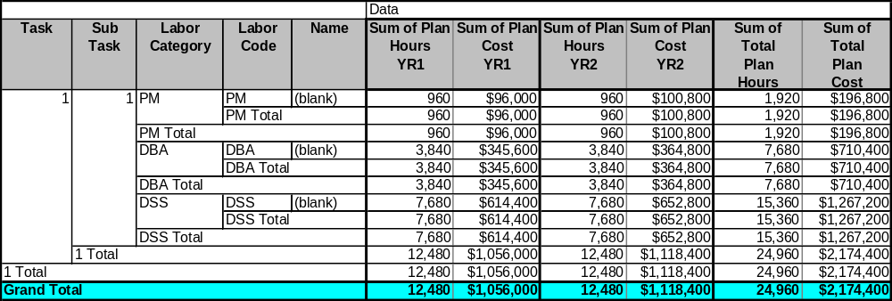
The Basis of Estimate (BOE) sheet provides you with a Pivot Table Report summarizing your initial project estimate. A completed BOE Chart for the example used above is shown in the figure below.
Some reformatting work is required to get the table into this format, but the work is relatively easy. This table can be used to provide a summary of the expected labor hours and cost to management to make a quick determination as to the Total Cost of the project versus the amount of Labor and Labor Hours required to execute the project. This table can also be integrated into a proposal should the proposal involve both the presentation of proposed Labor Hours as well as proposed Labor Rates/Costs.

View by Name
The View by Name sheet as well as the following two sheets can be used for labor leveling on each of the Tasks as well as reporting the estimated split of labor usage between different organizations supporting the project. The View by Name sheet shows the Full Time Equivalent (FTE) fraction for each person on the project team by Task. This will allow you to insure that a single team member is not split across several tasks with more than a single FTE worth of planned work.
You will simply need to refresh the Pivot Table once you have entered your new data into the details sheets to see the results. A completed version of the View by Name Report is shown below.
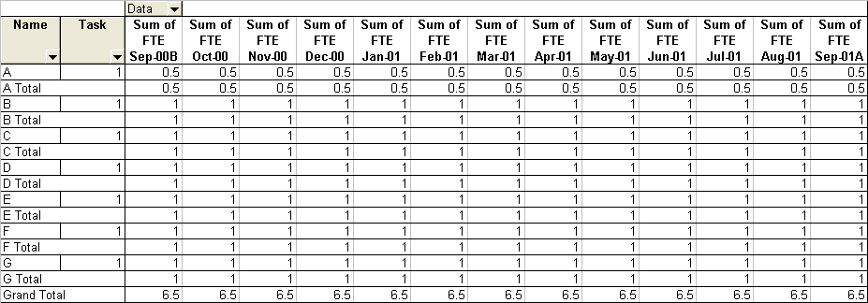

View by Organization
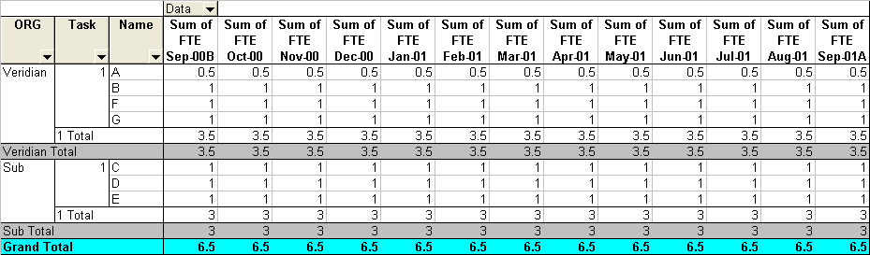
The View by Organization shows a similar Pivot Table to the View by Name Report with the addition of the Organization. This report is useful when the project you are managing has some form of disadvantaged subcontractor on the team. Very often, these disadvantaged subcontractors will have some minimum amount of work or FTE’s associated with their participation on the project. This report will allow you to plan the amount of work and the number of FTE’s that are assigned to the different organizations that are part of the project. A populated example of the View by Organization Report is shown below.

View by Task
The View by Task Report is identical to the View by Organization Report except that the hierarchy is flipped between Task and Organization. A populated example of the View by Task Report is shown below.

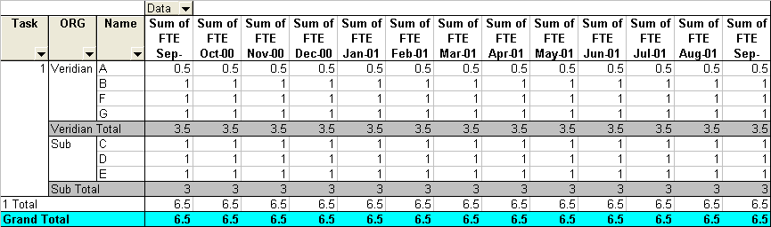

Details Sheets
The Details sheets are those worksheets within the workbook where most of the data will be entered. Each Details sheet contains the following sections:
- Initial Columns;
- FTE’s;
- Planned Hours;
- Planned Costs;
- Actual Hours;
- Actual Costs;
- EAC Hours;
- EAC Costs; and
- NTE Ceiling.
Each of these sections is clearly delineated by the column headings within each of the Details sheets and is described in a separate section below. Those sections above that are in italics are those sections where the majority of the data for the application is input. The remaining sections contain formulas based upon the data that has been entered. The formulas in these sections should not be changed!!

Initial Columns
The nine Initial Columns in each Details sheet provide the information required for keeping track of the values associated with each individual on the project team. This section consists of nine columns that contain a mix of empty cells that require data entry as well as data that has been inserted by the creation routines. These nine columns are the following:
- OBE;
- Task;
- Subtask;
- Labor Category;
- Project Role;
- Labor Code;
- Organization;
- Contract Role; and
- Name.
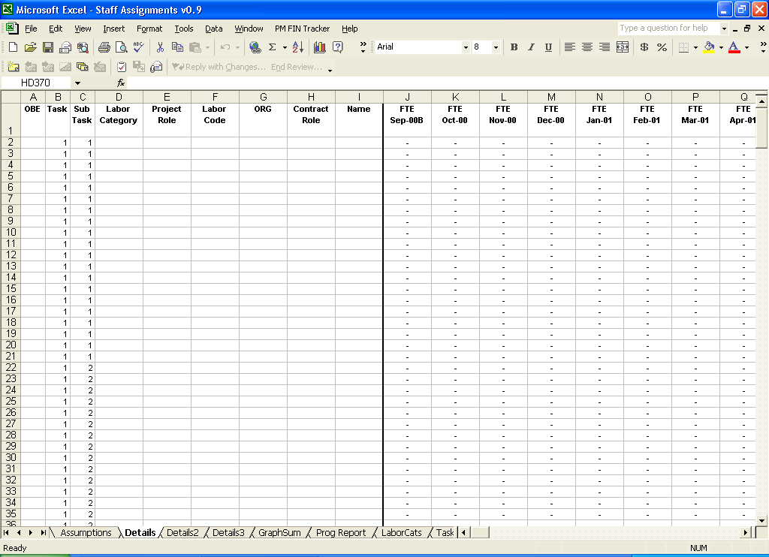
The Initial columns in a blank Details sheet are shown in the figure below.
The OBE column is used to mark those team members that have valid Actual Hours and, thus, valid Actual Costs, which are part of the cumulative costs to the project. Until you actually begin tracking a specific project, the OBE column should simply be left blank. Once a team member with Actual Hours and Actual Costs has left the team, you should place an “X” in the OBE column for that team member.
It may seem as though marking each OBE team member will unnecessarily clutter your worksheet. However, if you use the menu option Hide OBE, you can hide those rows that you are no longer using while still keeping the data that is required. This menu option is discussed below.
The Task and Subtask rows are filled in automatically by the Create routines. These simply serve as place markers to get you started. You should keep all the entries associated with a single Task in a single section (contiguous set of rows), since this is required for the bookkeeping associated with the EAC Charts. You should however feel free to change the Subtask assignments at will, since these are only used for internal tracking purposes based upon how the time on your project is recorded within you accounting system. For example, if you needed 10 rows for Subtask 1 and 30 for Subtask 2, you could simply change 10 of the 1’s to 2’s.
The Labor Category column holds the long name of a person’s Labor Category as the category was entered into the Labor Category column on the LaborCats sheet. Caution, you will need to enter the Labor Category on the Details sheets exactly the same way that it was entered on the LaborCats sheet, otherwise the Labor Code will come up as #REF in the spreadsheet, and Excel will not be able to properly lookup and compute any of the Planned Costs, Actual Costs or EAC Costs.
The Project Role column allows you to keep track of a person’s role and or responsibility on the project. On some Time and Materials contracts, the Project Roles will correspond exactly to the Labor Categories. In this case, you need not use this column. Caution, if you do not need to use any of the Initial Columns, hide do not delete these columns, since all Details sheets must be consistent, and the routines and formulas that are behind this spreadsheet all make the assumption that the Initial Column set consists of nine columns.
The Labor Code column contains a formula and should not be edited. This formula provides a consistency check for the entry in the Labor Category column. If #REF appears in the Labor Code column, you have entered an incorrect value into the Labor Category column, and you will need to go back and correct that value.
The ORG column should contain either Veridian or the name of the subcontractor that the team member belongs to. This will help you keep track of the fraction of the labor and the dollars that are spent on specific subcontractors. If the subcontractor is a small or disadvantaged business, any hours and dollars paid to that subcontractor will go toward Veridian’s small and disadvantaged business subcontracting goals. Once you place an entry in the ORG column, either Prime or Sub will appear in the Contract Role column. The Contract Role column contains a formula and should not be edited.
Finally, the Name column should contain the name of the individual team member.
An example of a set of completed initial columns is shown on the figure on the next page.

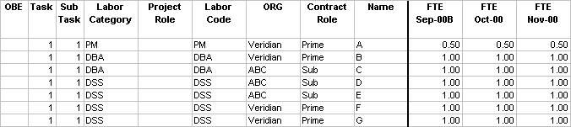

FTE Columns
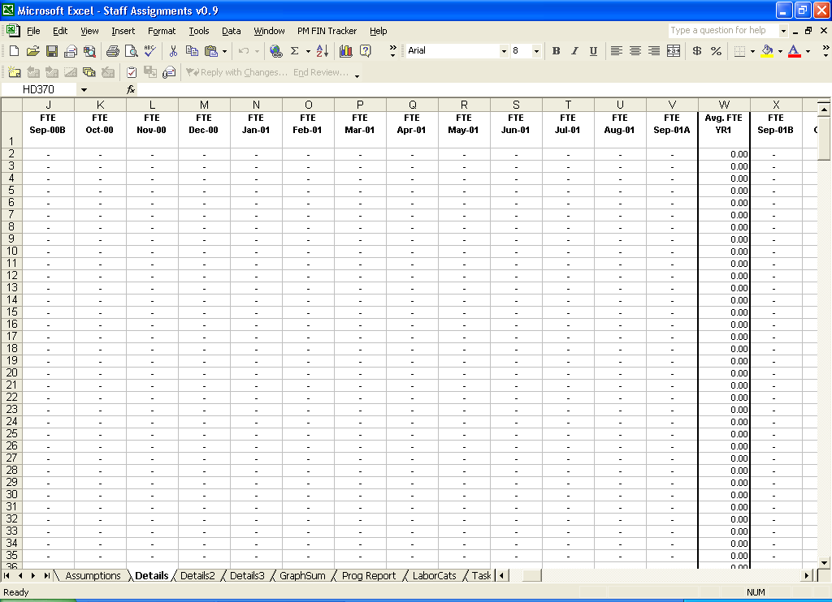
The next set of columns allows you to enter the Full Time Equivalent (FTE) fraction for a given team member for a given task for a given month. An example of the FET columns is shown in the figure below.
For planning purposes, you simply enter the fraction of an FTE that each individual will work on a given Task and Subtask for a given month across the entire project or at least across your current planning horizon. For large, complicated projects, you should use the Pivot Table Report on the View by Name sheet to ensure that you have not inadvertently overbooked any of your project team members.
An example of a set of completed entries for both the Initial Columns and for the FTE’s is given below.
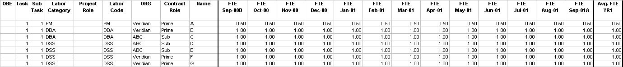
The chart above shows the Project Manager on the project half time (0.5 FTE) for the full first year of the project and all the other team members are full time (1.0 FTE) on the project for the first year.

Planned Hours Columns
The Planned Hours are derived from the FTE columns. These columns all contain formulas and should not be edited!! The only modification that you may choose to make to these columns is to the number of hours per month that are used by all the formulas. The hours per month are found in the row that is two rows below the last task row. This row is empty for all columns except the Planned Hours columns. The Creation routines are set up such that the number of hours per month for a full month is 160 and the number of hours for any split month is 80. I have estimated some projects for which the number of hours per month was 155 instead of 160. This depends upon the number of holidays and the number of vacation days that each team member has. An example of the Planned Hours columns is shown in the figure below along with the row that contains the number of hours per month.
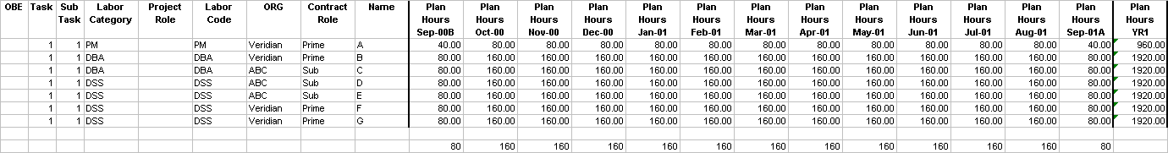

Planned Cost Columns
The Planned Cost columns are derived from the Planned Hours columns by simply multiplying the Planned Hours by the Labor Rates from the LaborCats sheet. The formulas in these columns are also defined in such a way that the Labor Rates defined for Year 1 are used to compute the Planned Costs for Year 1, the Labor Rates for Year 2 are used to compute the Planned Costs for Year 2, etc. Again, these columns contain only formulas and should not be edited!! An example of the Planned Cost columns based upon the Planned Hours above is shown in the figure below.
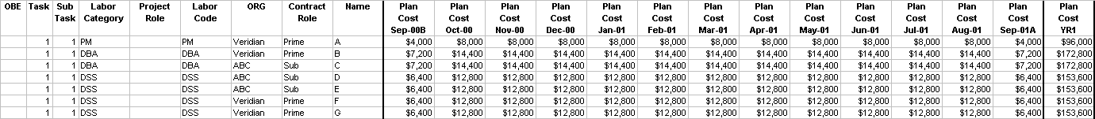

Actual Hours Columns
When you actually begin planning and tracking the execution of a project, you will be entering each team members Actual Hours into the Actual Hours columns. When the workbook is first generated, these columns are all blank. Month by month, you will transfer the Actual Hours worked either directly from your timesheets or from your project management/financial reporting system such as CostPoint. An example of the completed Actual Hours columns is shown in the figure below.
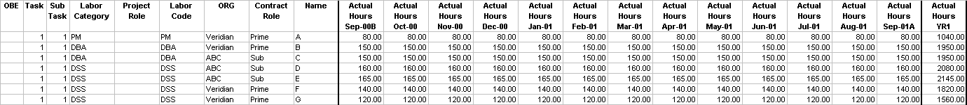

Actual Cost Columns
Similar to the values in the Planned Cost columns, the values in the Actual Cost columns are derived from the Actual Hours and the Labor Rates specified in the LaborCats sheet. The formulas in these columns are also defined in such a way that the Labor Rates defined for Year 1 are used to compute the Actual Costs for Year 1, the Labor Rates for Year 2 are used to compute the Actual Costs for Year 2, etc. Again, these columns contain only formulas and should not be edited!! An example of the Actual Cost columns based upon the Actual Hours above is shown in the figure below.
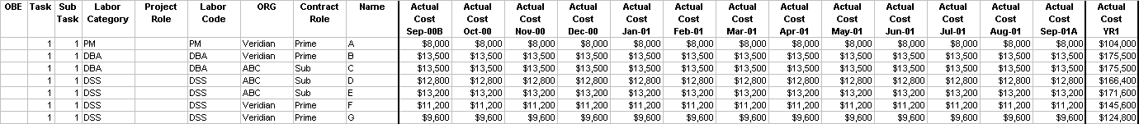

EAC Hours Columns
The values in the Estimated Actual at Completion (EAC) Hours columns are derived from the values of either the Planned Hours or the Actual Hours. The formulas in these cells are set up such that if there are Actual Hours entered, the EAC Hours columns will reflect the Actual Hours. If there are no Actual Hours (The Actual Hours columns are blank.), then the EAC Hours become the Planned Hours. Since the EAC Hours columns contain formulas that reference other cells within the worksheet, these cells should not be edited!! An example of the EAC Hours columns is given in the figure below.
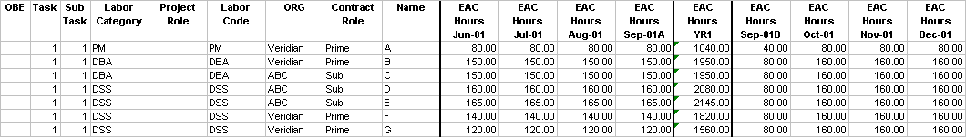

EAC Cost Columns
Similar to the values in the Planned Cost columns and the Actual Cost columns, the values in the EAC Cost columns are derived from the EAC Hours and the Labor Rates specified in the LaborCats sheet. The formulas in these columns are also defined in such a way that the Labor Rates defined for Year 1 are used to compute the EAC Costs for Year 1, the Labor Rates for Year 2 are used to compute the EAC Costs for Year 2, etc. Again, these columns contain only formulas and should not be edited!! An example of the EAC Cost columns based upon the EAC Hours above is shown in the figure below.
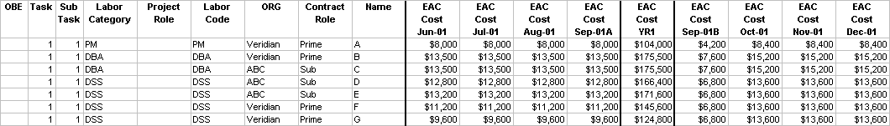

NTE Ceiling
The Not-To-Exceed (NTE) Ceiling column holds the value for the NTE Ceiling on a Task-by-Task basis. The value for the NTE Ceiling for a given Task should be entered in the first row that represents each Task. You do not need to copy it down, since the workbook reference the specific cell that represents the first row of data for each Task. An example of the NTE Ceiling value of $2.5 million for the first Task in the Project is shown on the figure on the next page.
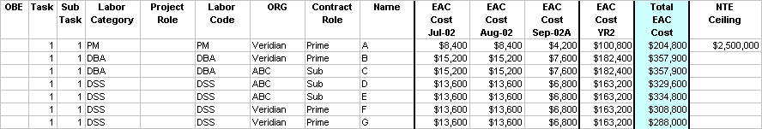

Estimating New Projects
Once you have created a full Project Financial Tracking Workbook, assembling an initial estimate for a new project is relatively easy. You will simply need to follow these steps:
- Enter the Labor Categories and Labor Rates that you will use. I often enter all possible Labor Categories and Labor Rates that I may use into the LaborCats sheet so that I have a large variety to select from. Entering a large variety of Labor Rates gives you the flexibility to re-price or re-estimate your project relatively quickly.
- Enter the FTE’s for the project team members. To estimate a full project, you will need to enter FTE’s for the entire duration of the project for all the anticipated project team members. When estimating new projects, you need not always use actual names for the team members – especially if you are planning to hire new team members to complete the project team. I will often use simple initials that indicate their roles on the project for the unknown team members. For example, I will use DBA for the database administrator or SD1 for one of the senior developers on the project.
- Refresh and reformat the Pivot Table Report on the BOE sheet. Once the report has been refreshed, all the data that you need to present a coherent estimate is present in the table. You can then use this summary table along with the Assumptions listed on the front sheet to communicate the full project estimate very effectively.
An example of a completed BOE sheet is shown in the figure below.
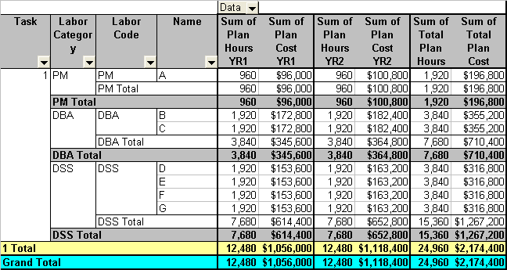

Tracking Existing Projects
You can easily track your project through execution by starting with the data that you used to produce the final estimate for the project. You need only follow these simple steps:
- Replace all the team member placeholders with real names in the individual Details sheets.
- Ensure that the data that is entered for the FTE’s and for the hours per month values match those that were used to produce the final estimate for the project proposal. If any of the values have changed during the final negotiations, make sure that the values for the FTE’s, Labor Rates and hours per month correspond to the final negotiate team size and final price.
- Enter the Actual Hours for each of the team members either from your project management reporting system (CostPoint) or directly from the timesheets that your project team fills out.
- Re-plan your project periodically to make sure that your final EAC still comes in under your NTE Ceiling.
- Prepare Progress Reports as required by your management or your customer.
- Reconcile the data in the workbook with customer invoices and time charging reports from your project management reporting system.
The only two special cases that you will need to deal with are the following:
- A current tem member leaves the team for another project or another job.
- A new team member joins the team from another project or another company.
Each of these two cases is described in a separate section below.

When a Team Member Leaves the Project
You cannot delete a team member from this workbook, if the team member has charged any hours to your project. These Actual Hours are part of the cumulative cost to the project and cannot be lost to the project. You can however effectively hide the data for the missing team member.
- Enter an “X” in the OBE column of the Details worksheet(s) that correspond to the team member that has left the team.
- Enter the final number of Actual Hours that the team member has charged to the project up to the point of leaving the team.
- Enter 0.0 for the Actual Hours for the remaining months of the contract.
- Hide all OBE rows.
These simple steps keep the data within the project consistent while hiding the data that is no longer relevant to planning and tracking the project.

When a New Team Member Joins the Project
When a new member joins the team, you simply follow these simple steps:
- If all the rows in the Task(s) that you expect the new team to work are full, then you will begin by adding at least one more row to the given Task(s). This is accomplished by Adding New Rows as described below.
- Enter all the Labor Category and other project data into the Initial Columns.
- Enter 0.0 for all the Actual Hours for all the months up to the point that the new team member joined the team.
- Enter the estimated FTE’s for the appropriate Task(s) that the new team member will work on.
- Track the new team member just as you would any other team member.

When a Tem Member Is Assigned a New Labor Category
When a current project team member is assigned to a new Labor Category based on experience or based upon a salary increase, you will need to enter the new information using the following steps:
- Insert a new Row(s) into the Task(s) that the current team member is working on.
- Enter an “X” into the OBE columns that correspond to the team member and the old Labor Category.
- Enter the Actual Hours that the team member worked on the specific Task(s) up to the date at which the new Labor Category took effect.
- Enter 0.0 for all the Actual Hours for all the remaining months of the project for the team member at the old Labor Category.
- Enter the data corresponding to the new Labor Category for the current team member into the blank Row(s) that you added in Step 1.
- Enter 0.0 for all the Actual Hours for all the months up to the point that the new Labor Category took effect.
- Enter the FTE’s for the work that the current team member will work under the new Labor Category.
- Track the current team member under the new Labor Category as you would any other team member.

Reconciling Data
You will need to periodically reconcile the data that you have in the workbook with the data that is reported by you project management reporting system and to the invoices that are sent to your customer. The reason for this is that both this workbook and the time accounting system have humans entering data, and humans will make mistakes from time to time. You will need to compare the hours that you have entered into the workbook with those hours recorded by the accounting system. The easiest way to approach this is as follows:
- Compare the total Actual Hours recorded in the workbook on a Task-by-Task basis with the total Actual Hours recorded in the accounting system. If the hours match, there is nothing else that you need do.
- If the total Actual Hours do not match, then you will need to match the Total Actual Hours for a given Task on a Person-by-Person basis. Once you have found the error, you can just correct the error in the workbook. The errors that you find should only amount to a small number of hours.
- If the number of hours difference amounts to several work weeks, then you will need to track down the exact root of the error – whether you made a mistake entering the data into the workbook or whether the team member made an error entering data into the time sheet or whether the individuals that process the timesheets made an error entering the data into the time accounting system (if you still use paper timesheets).
This process is crucial when you are coming close to contract close-out. You will want to spend right up to the NTE Ceiling and not over it. If you overspend, the difference will come directly out of profit, which is not good.

Other Operations
There are several menu items that allow you to perform some routine operations to facilitate the use and update of this application. These operations include the following:
- Undoing the Creation;
- Adding New Rows;
- Freezing and Unfreezing the Panes on the Details sheets;
- Hiding Rows; and
- Unhiding Rows.
Each of these operations is discussed in a separate section below.

Undoing the Creation
This menu option allows you to undo everything that you have done to the workbook and puts the workbook back to its original state. One strong word of caution – once you have created a workbook and filled it with a large amount of data all the data will be lost!! If you want to keep some of the data that you entered as a reference, I would suggest that you save a version of the workbook before you clear out all your work.

Adding New Rows
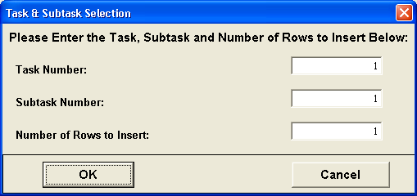
As you change the Assumptions that you used to estimate your project or as you start executing your project and team members come and go, you will need to add additional rows to the Details sheets to represent the new team members. This is accomplished by selecting the menu item, Add New Rows, from the PM FIN Tracker menu. When you select this menu item, the following dialog box will appear.
You simply enter the number of rows that you need added and the location in the Details sheet(s) terms of the Task and Subtask. Then hit OK, and the rows along with the appropriate formulas and default values will be added to the workbook.

Freezing Panes
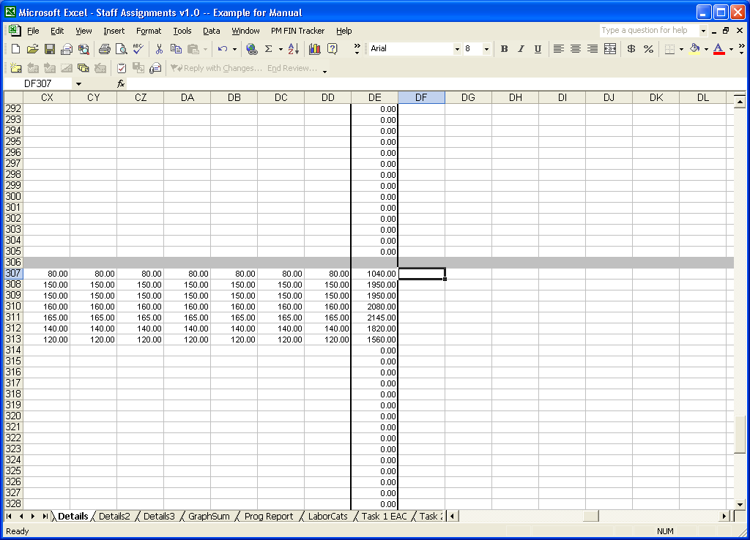
For large project that span several years, it is very easy to get lost in the specific details (cells) on the Details sheets. In this case, you can Freeze the Panes that contain the headers and the Initial Columns so that you know exactly what data you are looking at or what data you are examining within a given Details sheet. Below are shown two examples that are centered on the same cell within the Details sheet – the first does not have the Frozen Panes and the second one does.
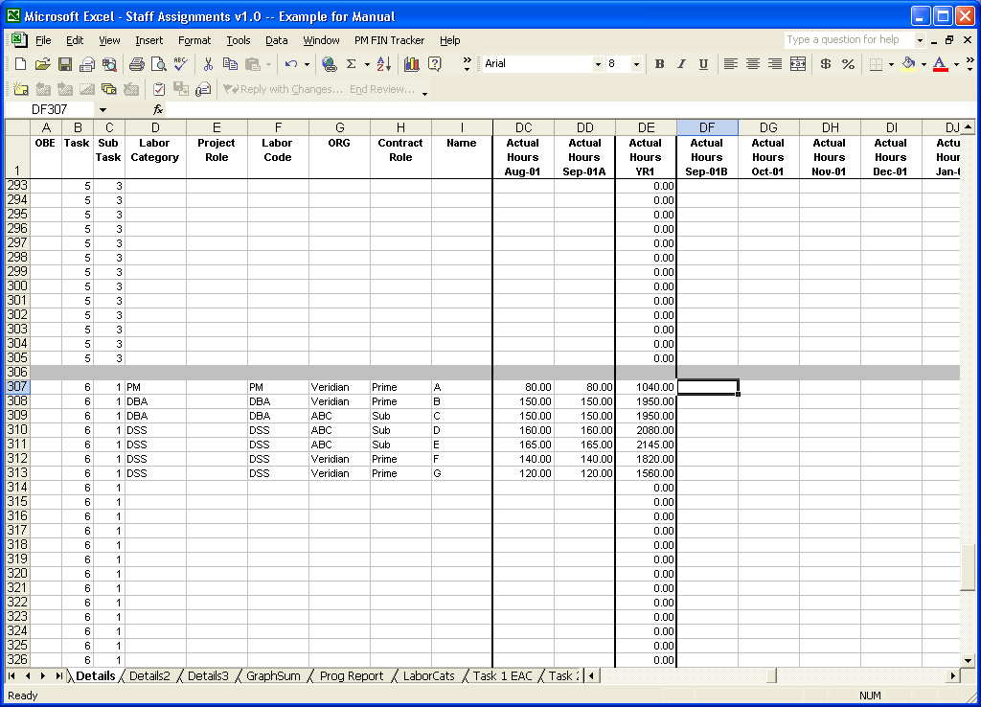
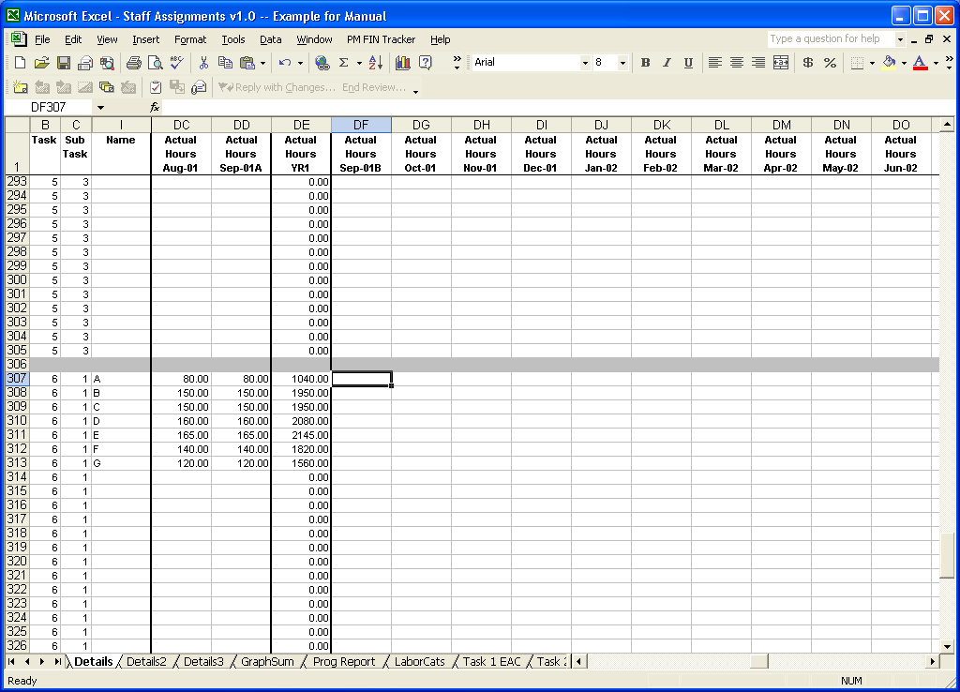
If you feel that the amount of screen space devoted to the Initial Columns leaves you with too little room to effectively enter data or examine the data in the worksheet, then you have the option of hiding many of the Initial Columns to reduce it to the minimum number for you to still be able to work effectively with the data. For example, the figure below shows this same worksheet for the case when all but the Task, Subtask and Name columns has been hidden.
The reason that I have included the option to Freeze Panes with this application and not used the functionality provided by the standard Excel menu options is that you cannot freeze both the first row as well as the first nine columns of the spreadsheet.

Unfreezing Panes
This menu option will Unfreeze the panes that were frozen using the Freeze Panes menu command. Again, you should use the menu command instead of the standard menu options provided with Excel, since you will have to go through several steps to Unfreeze the panes instead of a single step.

Hiding Unused Rows
When the Details sheets are generated, they are generated using the assumption that there will be a single row for every team member for every Task and Subtask in the project. Except for one or two team members with skills that are required across all tasks, most team members will be assigned to a single Task on the project. This will leave you with a large number of empty rows in the workbook. You can delete these rows so long as you do not delete the rows that have been grayed out between the separate tasks. If you expect that you will have some team turn-over, you can keep all the extra rows and simply hide them. You can Hide all the blank rows by selecting the Hide Unused Rows under the PM FIN Tracker menu. You do not need to worry about loosing these rows, since you can always Unhide them as described below.

Hiding OBE Rows
As described above under the section entitled When a Team Member Leaves the Project, you should enter an “X” in the OBE column next to the team member that left the project. This menu option will allow you to Hide all those rows that correspond to team members that have left the project team. This also allows you to keep the data in the workbook required to keep the project financial information consistent.

Unhiding All Rows
If you have Hidden rows during the process of tracking and re-planning your project, you may need to Unhide these rows either for the purpose of reconciliation with your accounting system or for the purpose of filling in empty rows. This can be accomplished by selecting the menu option Unhide All under the PM FIN Tracker menu.

Unhiding Unused Rows
If you have Hidden rows during the process of tracking and re-planning your project, you may need to unhide these rows for the purpose of filling in empty rows. This can be accomplished by selecting the menu option Unhide Unused under the PM FIN Tracker menu.

Unhiding OBE Rows
Finally, if you have hidden rows during the process of tracking and re-planning your project, you may need to unhide these rows for the purpose of reconciliation with your accounting system. This can be accomplished by selecting the menu option Unhide OBE under the PM FIN Tracker menu.

